United States Air Force Academy
South Florida Parents Club
NAME TAG ORDER FORM
Name tags are $20.00 each that does include shipping. Please print carefully.
Cadet Name:________________________________________ Year: __________
Name Tag #1: ________________________________________________________
Name Tag #2: ________________________________________________________
For additional name tags, please print names on back of form
Mailing Address: ______________________________________________________
City: __________________ State: _____ Zip: _________ Phone: ________________
E-mail address: _______________________________________________________
1 for $20.00 = $20.00 includes shipping
2 for $30.00 = ONLY IF SHIPPED TO SAME ADDRESS
Total payment Check# _______ $ __________________

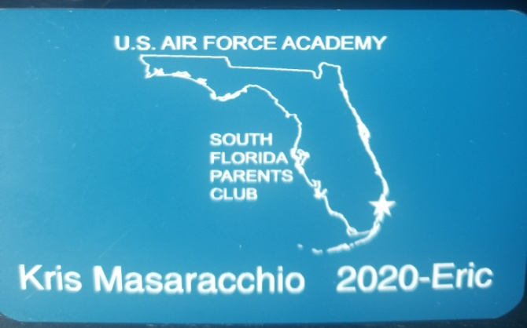
Make check payable to: USAFASFPC
Mail completed form and check to: Kris Masaracchio, 9015 Southern Orchard Rd. S., Davie, Fl 33328 pickrisann@bellsouth.net

